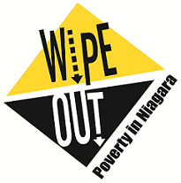
Niagara Poverty Reduction Network
Terms of Reference

Preamble
The Niagara Poverty Reduction Network (NPRN) works collectively to wipe out poverty in Niagara through education, collaboration, and advocacy to address poverty’s root causes. NPRN is a nonpartisan network but cannot identify as being apolitical because the issues around poverty are political.

Vision
All Niagara residents live above the poverty line

Mission
Niagara residents, businesses and organizations work together to improve the quality of life in Niagara

Values
Collaborative, Inclusive, Innovative, Integrity, Accountable

Goals
More residents, businesses and organizations know about poverty’s root causes
Objective: Education and Information
- NPRN is the leading source of information on issues affecting poverty in Niagara

More residents, businesses and organizations are engaged in taking action to address the root causes of poverty
Objective: Supporting Collaboration
- Increase opportunities for collaboration to better address the root causes of poverty

Objective: Advocacy Work
- Influence decision makers to improve policy, program delivery and resource allocation to reduce poverty

Attendance at Meetings
All NPRN meetings and Priority & Operations Table meetings are open to the public

Membership
NPRN acknowledges the benefit and importance of a wide and active cross-sectoral membership. The NPRN will broadly represent the communities of Niagara, non-profits, government, education, community leaders, the private sector and residents including people with lived experience. All members are expected to be respectful of other members and take direction from the Chair during meetings.

Membership Commitment
- Attend and actively participate
- Each member agency appoints one designate to represent the agency at NPRN who has the authority within the scope of their position to make decisions for their agency at the NPRN table
- Each member agency or individual is responsible for representation and active participation on at least one priority or operations table, and an ability to assist with some extra work should the need arise. It is agreed that the representative to sit on the priority or operations table may be different than the full committee member in recognition of specific expertise and time constraints
- Encourage interest and involvement in the round table through contacts with other organizations and members of the public
- Demonstrate respect for the strengths, skills and perspectives of other members

Membership Agreement
- Signed every two years

Coordinating Committee
Membership will elect the coordinating committee who will consist of:
- Chair and Vice-Chair of NPRN
- Priority & Operations Tables Facilitators
- Two to three members-at-large from NPRN
- Two ex-officio non-voting positions (Niagara Region and Convener)

Chair / Vice-Chair: Chair and Vice-Chair will be among the members of the network. These positions may be held for two, two-year terms for a maximum of FOUR years subject to NPRN confirming their appointment annually. Members must wait TWO years after a FOUR year term before applying for the same position.

Past-Chair: An outgoing Chair may remain an active part of the Coordinating Committee for ONE year following the end of their final term as a way to promote mentorship and knowledge transfer.

Convener: As an Ex-Officio member, the Convener’s main objective is to provide infrastructure support to the Niagara Poverty Reduction Network by: coordinating meetings of the Niagara Poverty Reduction Network, supporting the coordinating committee with agendas, minutes, resource materials etc.

Priority and Operations Table Facilitators
The Priority and Operations Table Facilitators will be drawn from the general membership and will coordinate meeting dates and locations. Facilitators will also attend the Coordinating Committee meetings to represent their table.

Frequency of Meetings
The Niagara Poverty Reduction Network meets FIVE times per year: January, March, May, September, and November.

Voluntary Annual Membership Fees
Membership to NPRN does not require a financial contribution, however there is an optional voluntary membership fee available to agencies, groups, or individuals. Membership fees will help fund NPRN activities and assists in meeting NPRN goals.

Guiding Principles for Recruiting Members
- Membership will be extended to service providers/organizations and individuals in Niagara who adhere to the network’s vision, mission, values and goals
- Members are required to sign the membership agreement

Terms of Reference Review & Membership Renewal
The Terms of Reference will be reviewed by the Coordinating Committee in October, in preparation for membership renewal.

Decision Making
Decisions will be achieved by consensus at the NPRN meeting. If consensus is not reached, a vote will take place. Only members who have signed the Membership Agreement will be allowed to vote.

Approval of a decision or passed motion requires 50% + 1 vote of the members present. Members must be present in order to participate in the decision making process. One of the members must be the Chair, Vice-Chair or their designate.

A vote does not bind any individual or organization to the decision or action to be taken.

Conflict of Interest
A conflict of interest is any situation in which a member of the Niagara Poverty Reduction Network, either for himself/herself or some other person(s), attempts to promote a private or personal interest that results or appears to result in the following:
- Interference with the objective exercise of his/her duties as a member of the Network;
- A gain or advantage by virtue of his/her position on the Network; and/or
- Some advantage for an organization with which the member is directly involved as a director, member, partner, shareholder, staff member, or has a financial interest.

Dispute Resolution
In the event that a dispute arises the members will attempt to negotiate the matter including involvement from other network members or a skilled facilitator/mediator as appropriate.

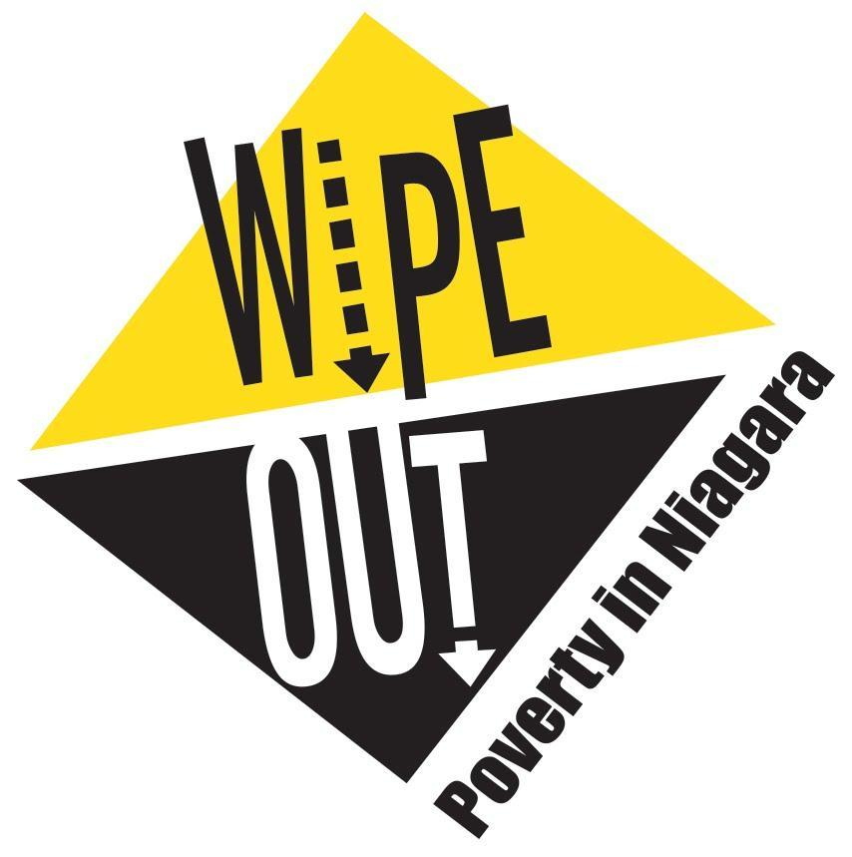
Niagara Poverty Reduction Network
Membership Agreement
January 2019 – December 2020

All Niagara Poverty Reduction Network (NPRN) meetings and task group meetings are open to the public

Organization Name:
Individual Name:
(if not associated with an organization)

Sector: | ☐ Private Sector ☐ Other: ____________________________
 | ☐ Government
 | ☐ Faith Community
 | ☐ Nonprofit

As a NPRN member you can be recognized in correspondence and on the NPRN website;

☐ I do want to have my name or the name of my organization appear on correspondence and on the NPRN website.
Name to appear on correspondence and NPRN website: __________________________________________

☐ I do not want my name, or the name of my organization to appear on correspondence and on the NPRN website.

On behalf of ____________________________________________________________________________,

I, _______________________________________ certify that I have read and understand the contents of the Niagara Poverty Reduction Network (NPRN) Terms of Reference document and agree with the NPRN vision, mission and goals.

I have also read and understand the Communication Policy, Logo Use Policy and agree with the procedures outlined in the documents. Both policies can be found online https://www.wipeoutpoverty.ca/aboutus

Organization Representative Will Be: _________________________________________________________

Alternate Designate Will Be: ________________________________________________________________

Date: _______________________

